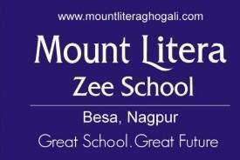

Annual Report

2024-25

**Strength of school students on roll (boys and girls)**

| **STUDENT'S STRENGTH SESSION 2024-25** | | | | |
| --- | --- | --- | --- | --- |
| **SR. NO** | **CLASS** | **BOYS** | **GIRLS** | **TOTAL** |
| **1** | **NURSERY** | **37** | **26** | **63** |
| **2** | **1** | **157** | **163** | **320** |
| **3** | **2** | **176** | **136** | **312** |
| **4** | **3** | **138** | **131** | **269** |
| **5** | **4** | **100** | **96** | **196** |
| **6** | **5** | **66** | **52** | **118** |
| **7** | **6** | **30** | **39** | **69** |
| **8** | **7** | **23** | **38** | **61** |
| **9** | **8** | **29** | **43** | **72** |
| **TOTAL** | | **756** | **724** | **1480** |

**ANNEXURE-3D**

**Staff List Teaching – 2024-25**

|  |  |  |  |
| --- | --- | --- | --- |
| Sr. No | Teacher Name | Designation | Edu. Qualification |
| 1 | Vandana Paul | Principal | M.A. B.Ed. |
| 2 | Jayanti Iyer | Vice Principal | M.A. B.Ed. |
| 3 | Saroj Kale | TGT | M.Sc B.Ed. |
| 4 | Madhavi Naidu | TGT | M.A. B.Ed |
| 5 | Gurpreet Singh Simar | TGT | B.Sc B.Ed |
| 6 | Nasrin Hussain | TGT | M.A. B.Ed. |
| 7 | Siddhant Verma | TGT | M.A. B.Ed. |
| 8 | Amruta Mokhade | TGT | M.Sc M.Sc |
| 9 | Manjiri Chorghade | TGT | M.A. M.Phil B.Ed |
| 10 | Sanjay Zade | TGT | M.A. B.Ed. |
| 11 | Pravin Pannase | TGT | M.Sc B.Ed. |
| 12 | Deepa Sharma | TGT | M.SC B.ED |
| 13 | Manoj Kohare | PTI | M. P.Ed |
| 14 | Bakul Meshram | Librarian | B.A M.Lib. |
| 15 | Kunal Aanandam | PRT | B.P.A. |
| 16 | Pranita Puranik | PRT | M.A. B.Ed. |
| 17 | Simran Simon | PRT | B.A. B.Ed. |
| 18 | Wanda J Mcdonald | PRT | B.A B.Ed. |
| 19 | Rose Mary | PRT | B.Sc B.Ed. |
| 20 | Supriya Chatterjee | PRT | B.Com B.Ed |
| 21 | Shipra Chatterjee | PRT | B.Sc B.Ed. |
| 22 | Jyoti Katole | PRT | B.E. B.Ed |
| 23 | Pramod Mankar | PRT | Sangeet Visharad |
| 24 | Puja Jain | PRT | MBA B.Ed. |
| 25 | Nikita Gandhi | PRT | MCA B.Ed. |
| 26 | Apeksha Kanojey | PRT | M.Com B.Ed. |
| 27 | Priyanka Purankar | PRT | B.Tech B.Ed. |
| 28 | Bhagyashri Akre | PRT | M.A. M.Ed |
| 29 | Manisha Ninave | PRT | M.A. B.Ed. |
| 30 | Atul Thakare | PRT | BFA |
| 31 | Praful Pimpalkar | PRT | B.E. Computer |
| 32 | Kanchan Manjre | PRT | MCA B.Ed. |
| 33 | Priyanka Borkar | PRT | MCM B.Ed. |
| 34 | Poonam Kurve | PRT | M.Sc B.Ed. |

|  |  |  |  |
| --- | --- | --- | --- |
| Sr. No | Teacher Name | Designation | Edu. Qualification |
| 35 | Sunidhi Basantani | PRT | B.Sc B.Ed. |
| 36 | Preeti Giradkar | PRT | B. Com PGDCCA |
| 37 | Swati Gedam | PRT | MCM |
| 38 | Shweta Kolhe | PRT | M.Sc B.Ed. |
| 39 | Ankita Palaskar | PRT | BFA |
| 40 | Anagha Harkande | PRT | M.A. B.Ed |
| 41 | Ashwini Shende | PRT | M.Sc B.Ed. |
| 42 | Sarita Panchware | PRT | M.Sc B.Ed. |
| 43 | Chaitali Makhe | PRT | B.Sc. B.Ed |
| 44 | Varsha Parashar | PRT | M.Sc. M.A. B.Ed. |
| 45 | Suman Purohit | PRT | M.A. B.Ed. |
| 46 | Priyanka Godghate | PRT | M.A. B.Ed. |
| 47 | Gayatri Shambharkar | PRT | M.A B.Ed. |
| 48 | Aditya Gandhi | PRT | BFA |
| 49 | Archana Thool | PRT | B.Sc B.Ed. |
| 50 | Kirti Singh | PRT | M.A. B.Ed. |
| 51 | Smita Titarmare | PRT | B.Sc B.Ed. |
| 52 | Ruchi Shrivastava | PRT | B.Com, MBA B.Ed. |
| 53 | Suvarna Kale | PRT | M.Sc B.Ed. |
| 54 | Umeshwar Barapatre | PRT | Sangeet Visharad, D.T.Ed. |
| 55 | Sarika Netanrao | PRT | B.A B.Ed. |
| 56 | Pallavi Sheoday | PRT | M.A. B.Ed. |
| 57 | Dipti Sohoni | PRT | B.Sc. B.Ed. |
| 58 | Ifrah Ahmed | PRT | M.A. B.Ed. |
| 59 | Savita Deshmane | PTI | M.A. B.P.Ed. |
| 60 | Prachi Banode | PTI | Physical Education |
| 61 | Anitha Balkrishnan | Special Educator | B.Com B.Ed, in Special Education |
| 62 | Amar Naise | Wellnees Teacher | B.Sc. M.A. in Psychology |
| 63 | Monika Singh | Asst Librarian | M.Lib. |
| 64 | Shilpa Borundiya | NTT | M.A. B.Ed. |
| 65 | Renuka Deshmukh | NTT | B.Com Montessori Training |
| 66 | Swati Nimawat | NTT | M.A. B.Ed. |

**Institutional planning**

***“An educational brand is a set of expectations,***

***Memories, stories, relationships, which when taken together, Account for a parent’s decision,***

***To choose one school over the other”***

### - Seth Godin

**OUR VISION**

Mount Litera Zee School will provide a complete and unique educational experience for the child, preparing him / her for a successful life in the contemporary society.

***The vision of Mount Litera Zee School envisages:***

* To create an excellent educational institution synthesizing the human values with the highest quality of teaching–learning using modern technology-driven tools for preparing a well-rounded personality for our society.
* To shape global minds on the Indian soil.
* To ensure this, the school will give every student an access to world-class infrastructure, and an innovative curriculum that promotes the all-round development of the child imbibing traditional values.

**OUR PHILOSOPHY**

**Every child is unique**: It is a well-known fact that no two thumbprints are alike. In the same way, we believe that every child is born unique. Each child has a unique brain network that shapes how she absorbs and responds to stimuli. One way of teaching does not work for every child. We need to teach the way they learn, not force them to learn the way we teach.

**Education should foster real understanding**: Understanding is different from acquiring information. Mere acquisition of information relies on memory, understanding relies on conceptual clarity. Schools are not assembly lines of syllabus and exams. We help children make meaning of life and develop the muscle to lead life effectively. For this, we go beyond academics to include life skills, values and habits.

**Real understanding comes from an integrated approach**: We have a vision of the child we aim to graduate and everything in our schools is designed around that vision. Building design, pedagogy, Educator, curriculum content, activities and examinations – all are integrated to achieve this vision. A school is an eco-system where different factors have an effect on the child. Educator, curriculum, assessments, environment, infrastructure, activities all come together to nurture the unique potential of the child.

**OUR MISSION**

* To prescribe and implement a curriculum for physical, mental, emotional, spiritual and intellectual enlistment for achieving multifaceted development and growth of the younger generation.
* To foster an environment for the development of leadership qualities, team spirit, sportsmanship, self-esteem and other social attributes to prepare children for facing real life challenges.
* To create an ambience that provides a continuous encouragement and motivation for enhancing initiative and drive, innovativeness, creativity, original thinking and insatiable appetite for knowledge.
* To prepare the future generation to face the challenges of globalization, galloping technology and social changes in the 21st century.
* To nurture in every child conventional Indian ethics, culture and ethos with a judicious blend of modern values and technology to churn out a perfect global citizen.
* Blend modern education with our rich heritage ensuring a gradual metamorphosis in thought and action to prepare the new generation to lead our country into the future.
* To make children aware of the significance of an eco-friendly environment.
* To nurture the unique potential in every child.

**Values in Education endorsed by MLZS Ghogali Besa: An overview of school.**

**Value 1**: **Instructional excellence**

* The entire curriculum is met out by adhering to the Annual calendar which is strategically planned in terms of high expectations, professional development and academic excellence.
* The learning goes beyond the textbook. The Educator enriches the topics with activities, curiosity, questioning, and research.
* The Educator is committed to excellence in teaching.
* Learning process is channelized towards attainments in grades and competitions.

**Value 2: Professional Capacity building**

* MLZS Ghogali Besa is committed to select Educators of quality with requisite qualification and skills, then enriching them with training programs.
* The Cluster training at Mount Litera Zee School, Besa, Nagpur, in June 2024.
* Sessions focused on MLZS Philosophy, innovative pedagogy, digital platforms, and new curriculum designs, which highlights emotional intelligence, value education, and career guidance.

**Value 3: Mentoring instructions at MLZS Ghogali Besa.**

* This helps to build a reputation of impeccable credentials in academics.
* Helps to identify training needs to meet educational goals of the school.
* Mentoring helps to identify and provide opportunities to explore ideas and try out different methodologies of teaching.
* When a close watch is kept it becomes easier and faster to identify the loop holes in the teaching learning process and provide appropriate solutions through microteaching.

**Value 4: Operational Effectiveness**

* Appropriate human resource allocation,
* Support of technology in terms of smart class, MLL app and other infrastructure helps to enhance the quality of school life and provide opportunities for excellence.

**Value 5 : Family and community engagement.**

* We at MLZS Ghogali Besa try to involve parents, professionals and other stakeholders in various activities at school. We hope to create a harmonious sync with the parents, so they are involved in the various dimensions of the child’s growth.

**Institutional Planning for Kindergarten**

With the advent of “New Academic Session” at Mount Litera Zee School Ghoghli Besa commences its scholastic activity

**Induction Program:** The academic session started with a five day Induction programme ‘Genisis’ which is a way to introduce the new appointees(Educators) with the working culture of MLZS. Meticulously curated training program aims to inspire Educator to learn and grow for the Academic session 24-25. We have a strong Mentor-Mentee system which helps in understanding the functioning and academic needs.

**Parent Orientation**

Parents as stakeholders have always been our prime partners in providing effective and constructive education to the children. The academic year began with an ‘Orientation program’ which was conducted-to help the parents decipher the schools philosophy, pedagogy in accordance with the CBSE.

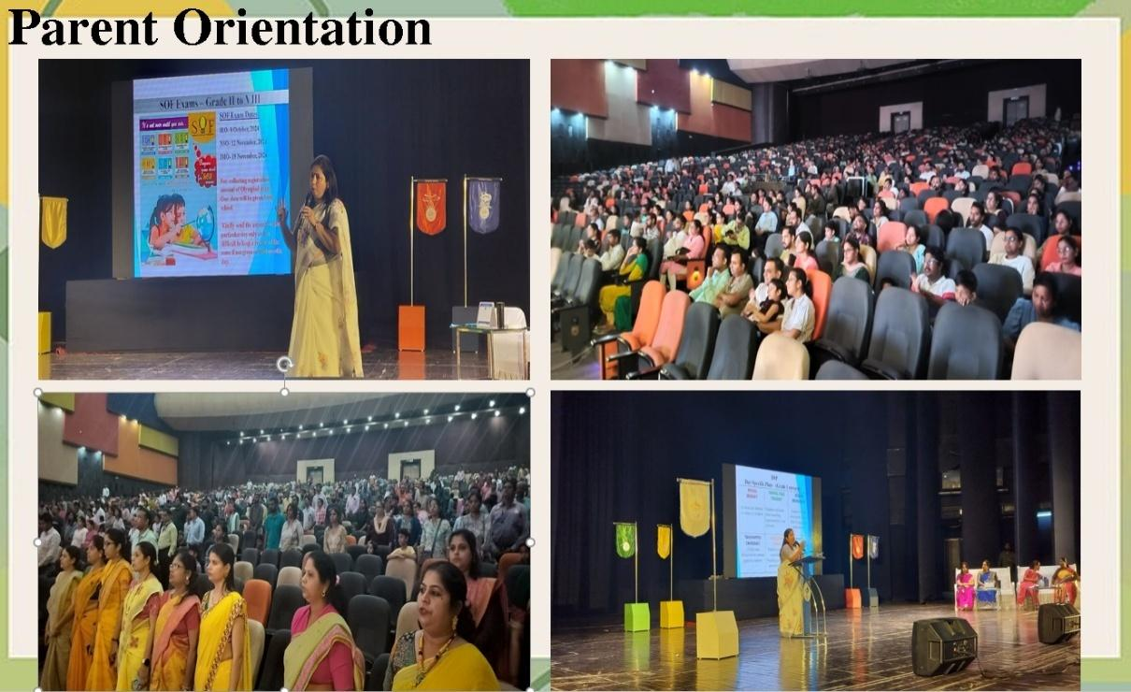The parents were introduced to the teaching staff and updated with school policies and procedures. ‘What is right for the child’ and the ESP ‘emerging student profile’ was also discussed. The session was a sincere effort made by the school to express gratitude to parents and request to join hands in reinforcing the learning process of the children. The Parents were informed that the School focuses on the holistic development of every child, special care to provide learning platform to showcase the talent of the children.

**HO Training By RSD**

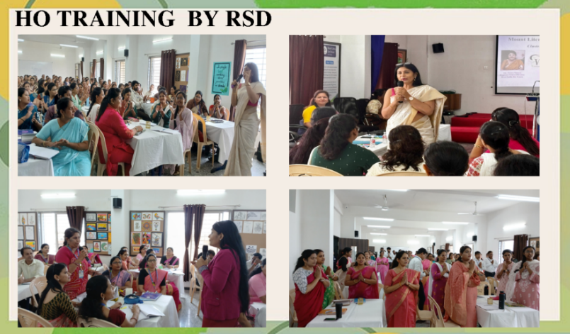Head office training by the Regional School Director is an ongoing learning process. Staying updated is the key to success in any field. Our Educators constantly strive to stay updated, by attending workshops and various training programs. The school facilitates the participation of teaching faculty in a wide range of workshop seminar, training programs to enhance the knowledge of the subject and keep them abreast with changing paradigm in education.

The parents were introduced to the class libraries that MLZS GhogaliBesa has adopted to encourage language learning.

* We also introduced to the parents the concept of teaching using multiple intelligences in the teaching learning process.
* The Educator gained confidence, interesting creative inputs were learnt from hosting a workshop. The appreciation the Educator got from the parents also help to bring about new energies and new enthusiasm in the Educator.

Shaped and mentored the Educator of MLZS Ghogali Besa have devised a program in Kindergarten that is:

* Child Centric which generates enthusiasm and interest in the child. The Educators ensure that every day is colorful full of joy and fun so that the children are happy and enthusiastic about to coming school every day.
* This consistency helps the child develop physically, intellectually and emotionally.
* The Educator are constantly adapting different learning life styles and experimenting with new ideas.

**Languages English/Hindi**

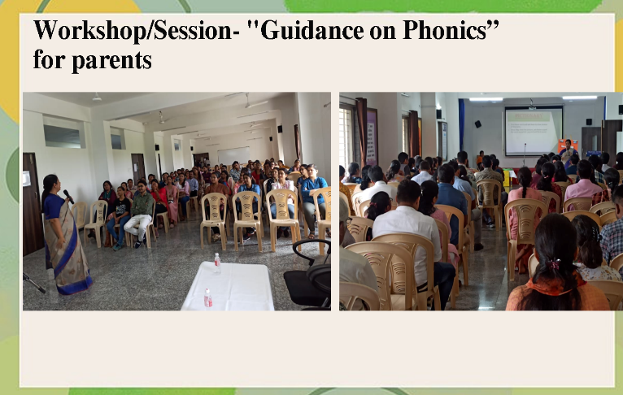Language learning emphasizes fluency in phonics, increasing vocabulary, comprehension of the spoken language and recognition of daily objects in the purview of the child. MLZS Ghogali Besa has tried to use tools of multiple intelligence to implement the goals of language learning

**Building cultural, Emotional, environmental Values for the holistic development of child.**

Step into the Illume Room at MOUNT LITERA ZEE SCHOOL- a space where curiosity meets creativity! Designed to spark imagination, this unique learning environment uses interactive tools, sensory play, and experiential activities to make concepts come alive. Here, every child explores, experiments, and excels in a world of endless possibilities. Come, let your child discover the joy of learning like never before!

**Academic performance**

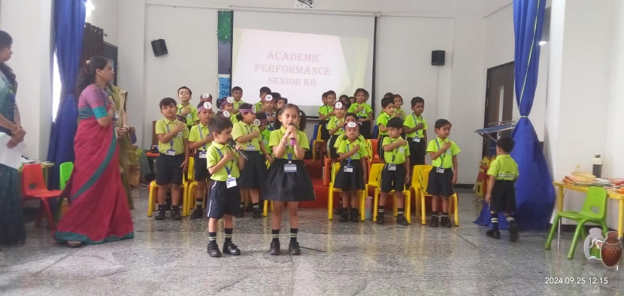

**Academic performance** is more than just grades—it’s about building self-confidence and overcoming stage fear. Through fun-filled activities like storytelling, group presentations, and hands-on learning, we help your little ones shine in every aspect. Watch them grow into confident, expressive, and happy learners ready to take on the world!

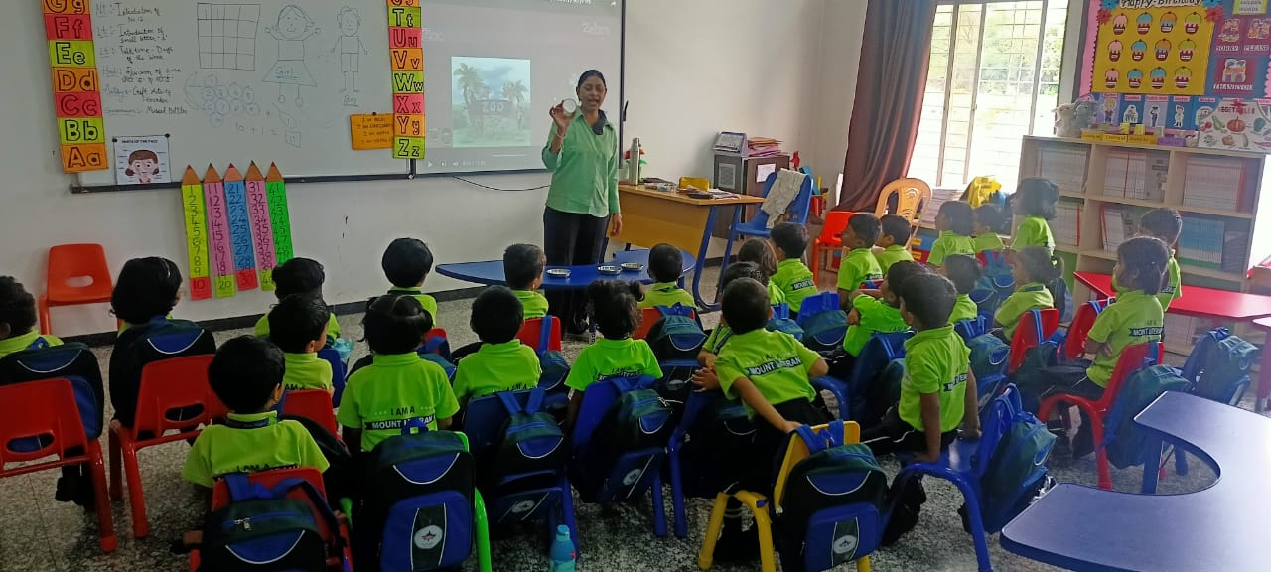**Happy Hours**

We make the first steps of learning joyful with our unique Happy Hours! These specially designed sessions help children get comfortable with their surroundings, bond with facilitators, and ease into school life through fun activities. It’s the perfect way to make their transition smooth, exciting, and full of smiles. Because happy kids learn best!

Every day is an adventure with our exciting in-house events! From cultural celebrations to theme-based days and fun competitions, our events inspire creativity, teamwork, and confidence. These engaging activities ensure holistic development while creating unforgettable memories for your little ones.

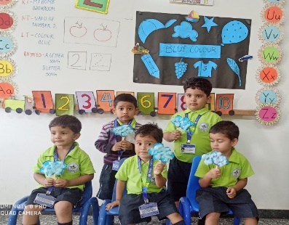**Exploring the Importance of Color in Nature**

In a recent educational activity, participants explored the significance of color in fruits, vegetables, insects, and animals. The colors of fruits and vegetables are directly linked to their nutritional benefits, with red foods like tomatoes offering heart-healthy antioxidants, green vegetables like spinach boosting immunity, and yellow/orange produce like carrots promoting healthy skin and vision.

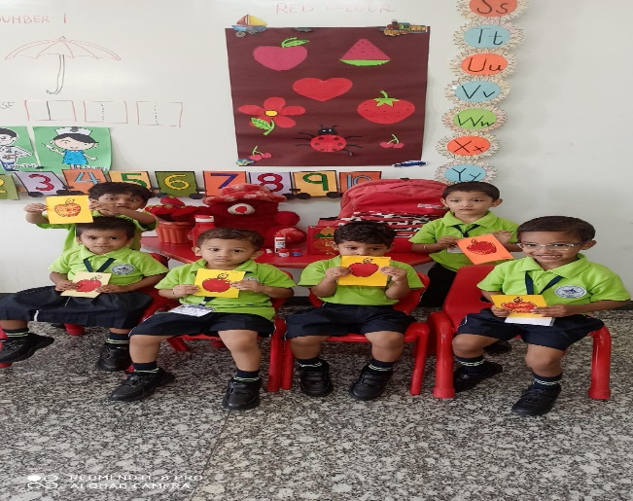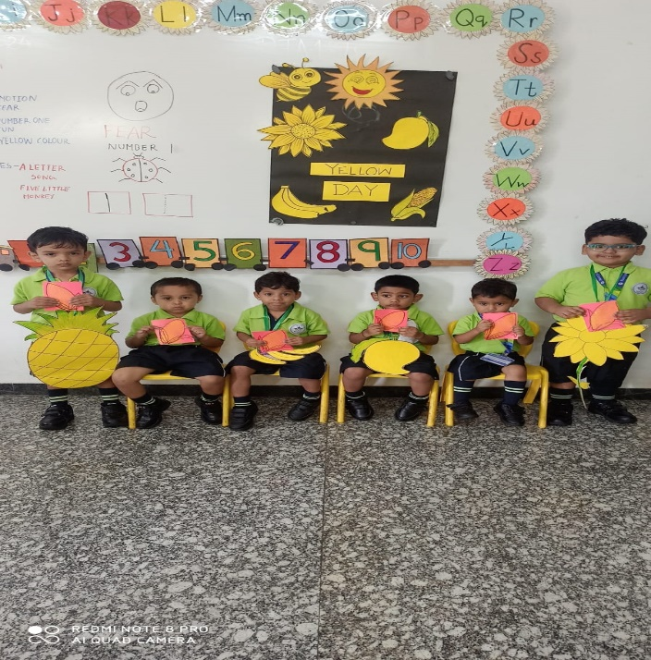Insects and animals also play a crucial role in color patterns. Bees are drawn to brightly colored flowers for pollination, while many animals use color for camouflage and survival. This activity highlighted how colors in nature are not just visually striking, but essential for health, biodiversity, and ecological balance.

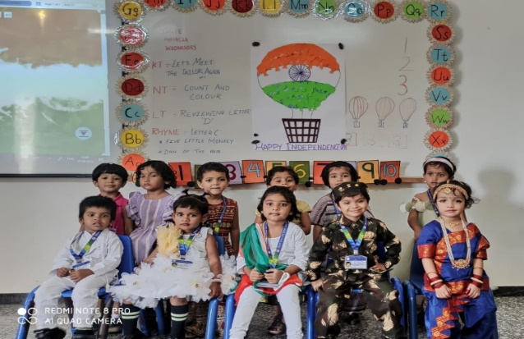**Celebrating Independence Day**

On Independence Day, we commemorate the spirit of freedom, unity, and progress. we reflect on the sacrifices made by our leaders and citizens, and recognize the ongoing efforts to build a stronger, more inclusive society.

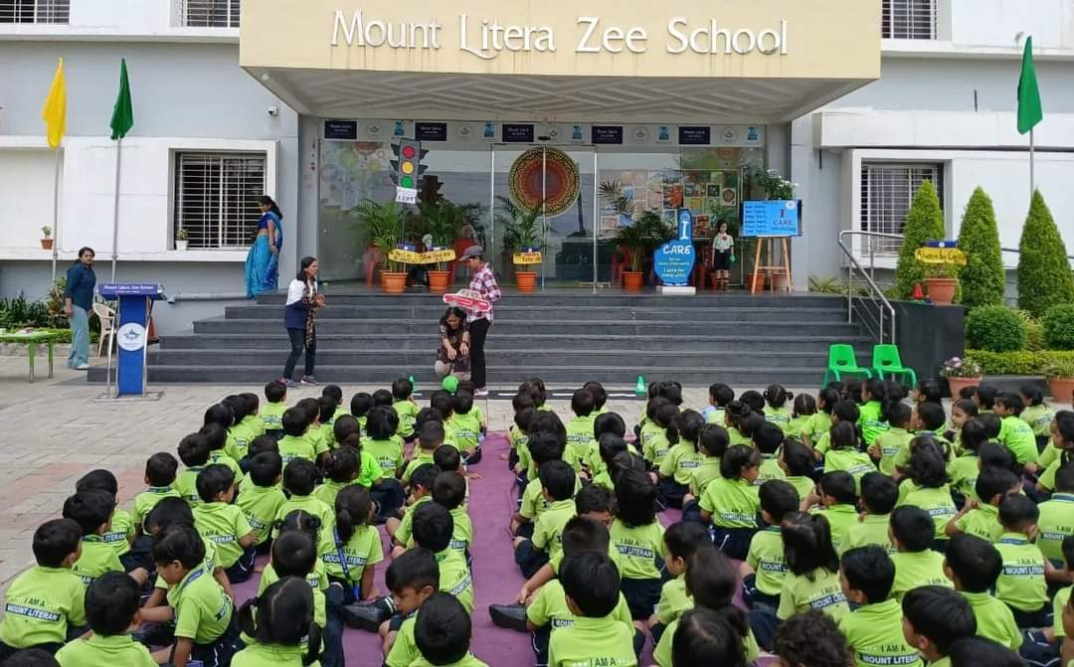**Promoting Self-Care and Well-Being**

"I Care for Myself" is an initiative aimed at encouraging individuals to prioritize their physical, mental, and emotional well-being.

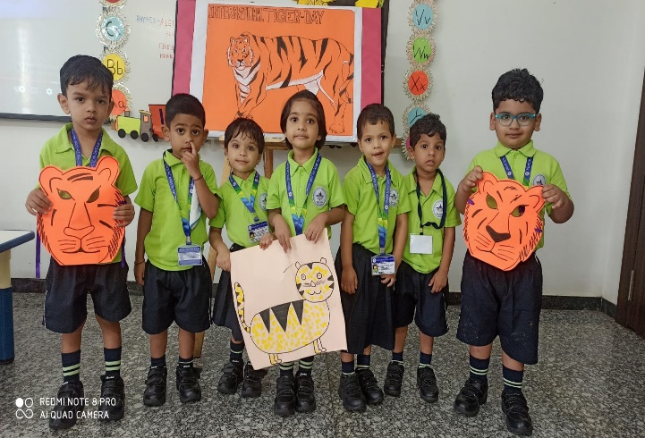

**Celebrating International Tiger Day**

International Tiger Day, celebrated every year on July 29th, aims to raise awareness about tiger conservation and the challenges these majestic creatures face

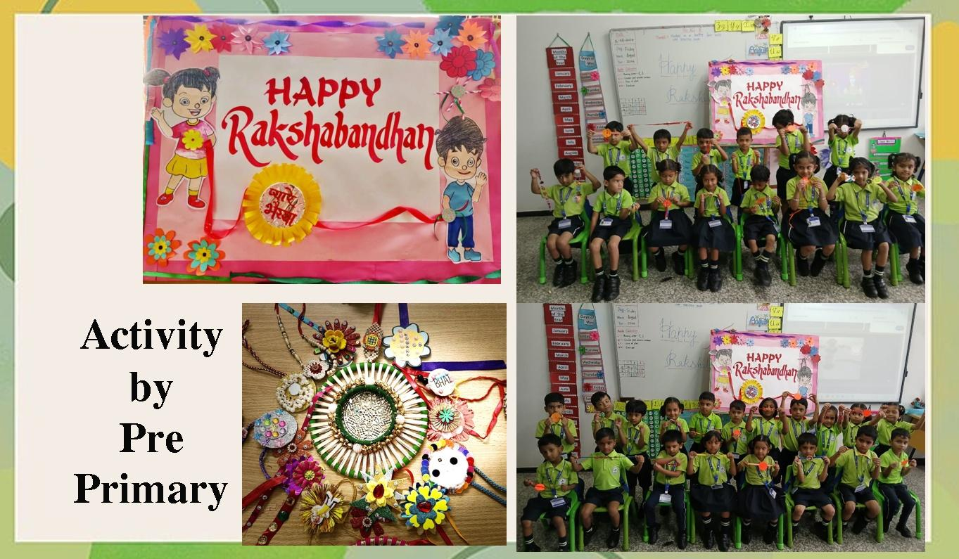

**Celebrating Raksha Bandhan**

Raksha Bandhan celebrates the loving bond between brothers and sisters. Sisters tie a rakhi on their brothers' wrists as a symbol of protection and affection. The festival promotes unity, love, and the importance of family bonds.

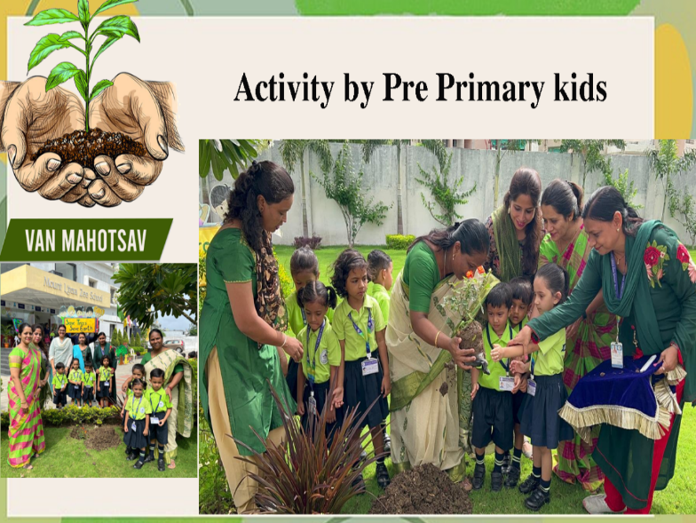**Plantation Drive for a Greener Future**

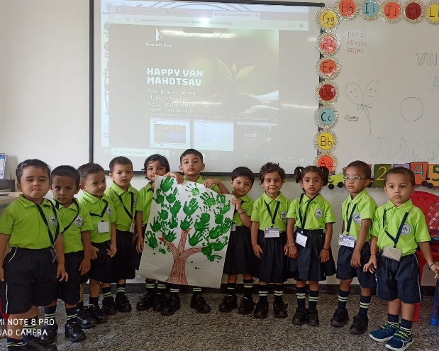A successful plantation drive was held to raise awareness about environmental sustainability.

**Celebrating Tanha Pola in School**

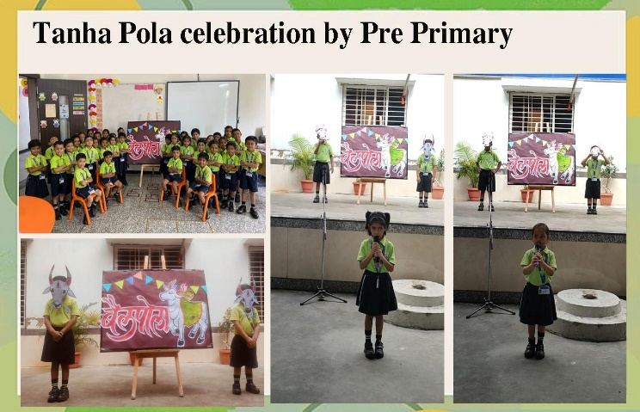**Tanha Pola**, a festival dedicated to honoring the hardworking cattle that play a crucial role in farming. Students participated in cultural activities, showcasing the importance of cattle in agriculture.

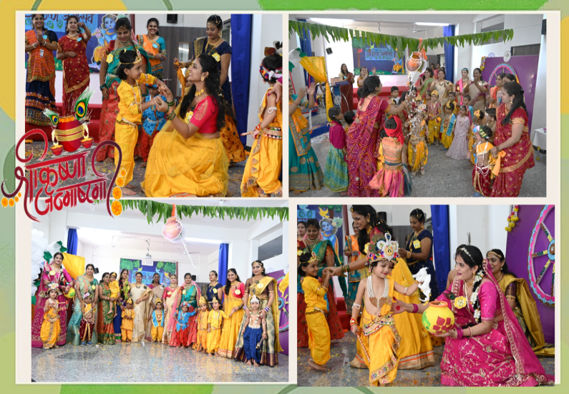

**Celebrating Janmashtami in School**

**Janmashtami**, the birth of Lord Krishna, with great enthusiasm. Students participated in various activities such as devotional singing, dancing, and drama performances, showcasing stories from Lord Krishna’s life. An amalgamation of Family that learns and grows together

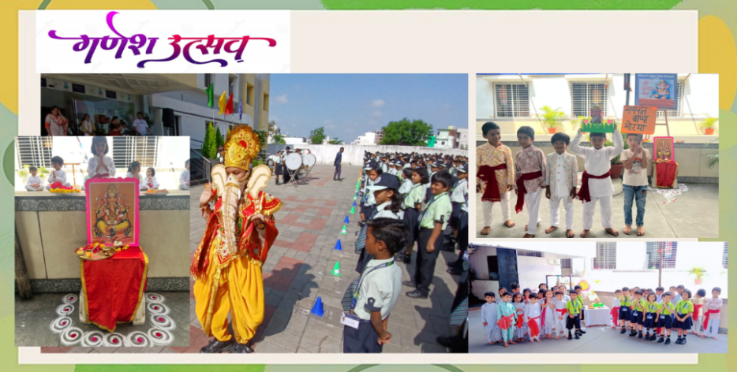**Celebrating Ganesh Utsav in School**

The school recently celebrated **Ganesh Utsav**, a vibrant and joyous festival honoring Lord Ganesha, the remover of obstacles.

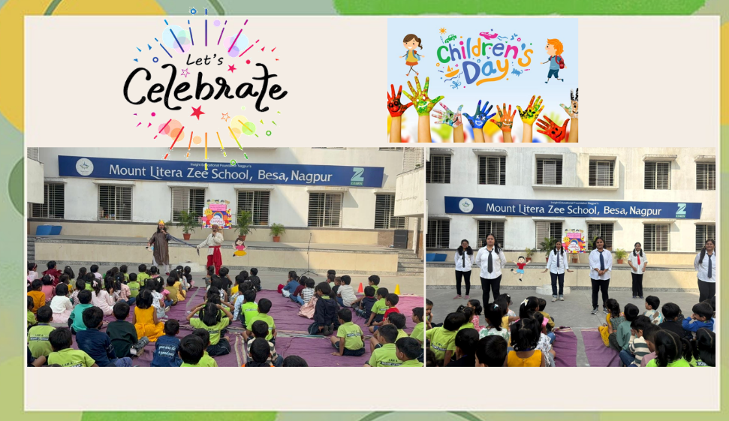**Celebrating Children’s Day in School**

**Children’s Day** with great enthusiasm to honor the spirit and innocence of children. The day, which marks the birth anniversary of Jawaharlal Nehru, was filled with fun activities including games, cultural performances, and interactive sessions.

**Celebrating Christmas in School**

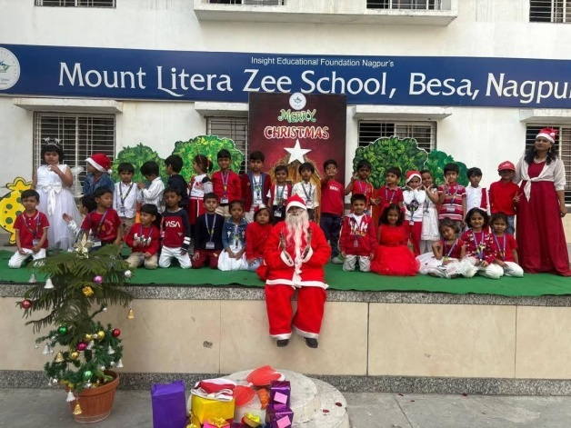

Jingle bells, jingle bells, jingle all the way!

Santa Claus is on his way, riding merrily on his sleigh…

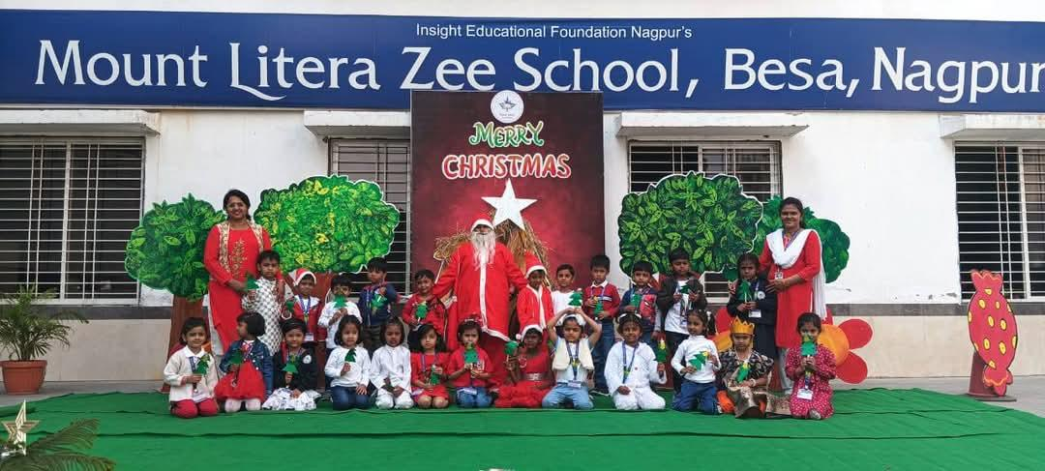

Mount Litera Zee School, Besa, joyfully celebrated Christmas with great zeal and enthusiasm. As part of the festivities, our Junior KG children presented a lively dance performance that captivated everyone. The little nursery angels brought the story of the Birth of Jesus to life, refreshing our hearts with its divine message. Adding to the cheer, our talented Senior KG children delivered heartfelt speeches, sharing their joy and excitement for this special occasion.

**Sing along**

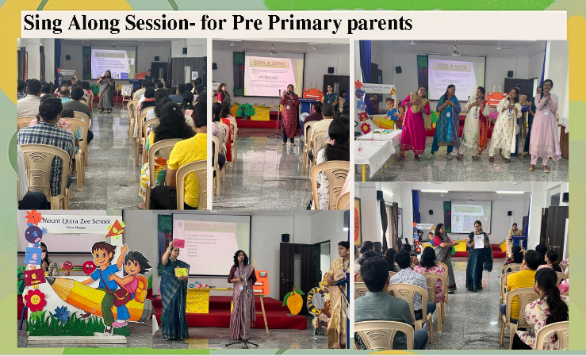Mount Litera Zee School , Besa had an amazing time at the sing along session conducted on 10th of August . The session with the parent was a huge hit, filled with interactive activities , music , rhymes action songs that made learning phonics fun and engaging . Parents participated enthusiastically and expressed their interest to get associated with more such learning sessions.

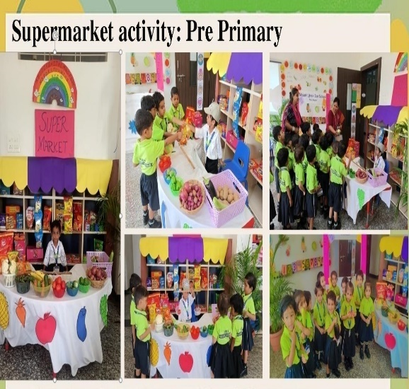**Supermarket Activity**

A fun and educational supermarket activity for pre-primary children can be a "Supermarket Role Play" or "Mini Supermarket Adventure." This activity helps children learn about different types of food, money, and basic shopping skills in a playful and engaging way.

**Grandparents Day Celebration**

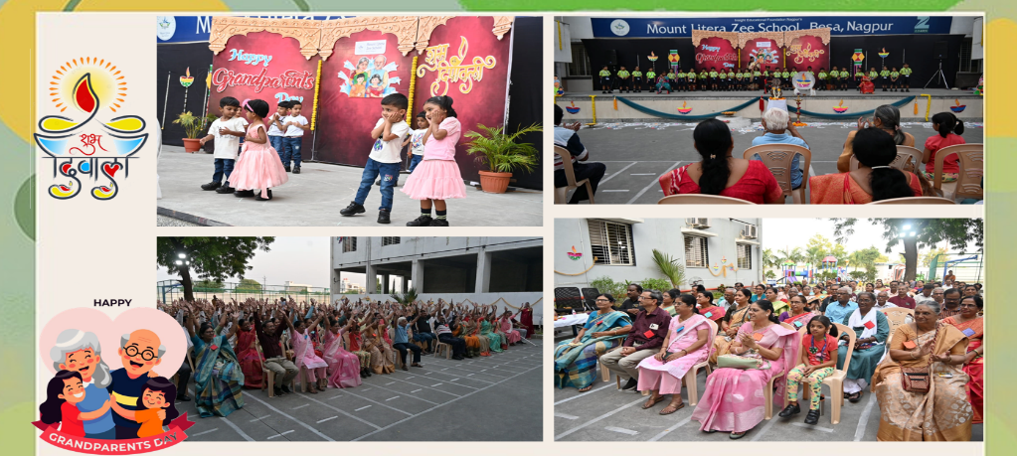A **Grandparents Day Celebration** in a **Pre-Primary** setting (for young children) is a wonderful opportunity to teach kids about family bonds, respect for elders, and create lasting memories with their grandparents. Celebrating **Diwali** (the Festival of Lights) in a **Pre-Primary** classroom is a wonderful way to introduce young children to our cultural traditions, colors, and the concept of light overcoming darkness.

**Oral Hygiene Workshop**

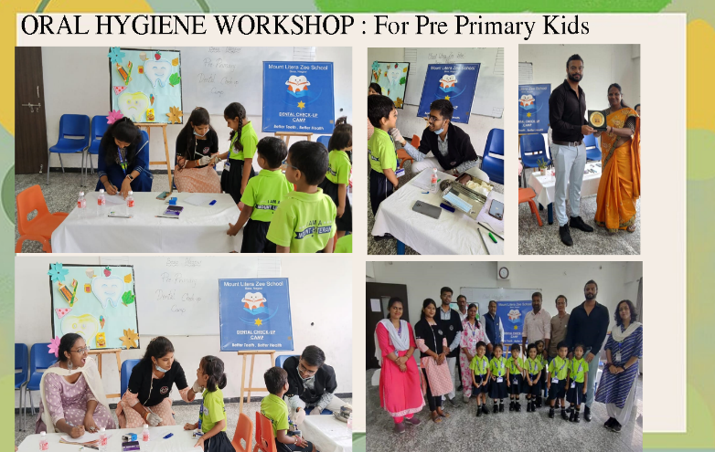Oral Hygiene Workshop organized at MOUNT LITERA ZEE SCHOOL BESA, NAGPUR. The school has always been on the forefront   to address the concerns of overall health and wellbeing of the children.

The Pre Primary Grade kids were excited and curious  to  see a Team of Doctors with their  sophisticated  instruments to examine the teeth of the  the young ones.

Dr Jay Deshmukh,Dr Bhumi Tarar and Dr Sarthak Mankar checked and gave their Observation .

They also guided the students on the importance of brushing the teeth and  measures to avoid  dental and oral problems .

Vice Principal Madam  Jayanti Iyer appreciated the guidance of the dental team  by presenting a memento and acknowledged the efforts  of pre primary Grade Educators along with convenorship of Mrs Ashwini Padoliya in organizing the workshop.

**Field Trip : Nursery and Jr. KG Students**

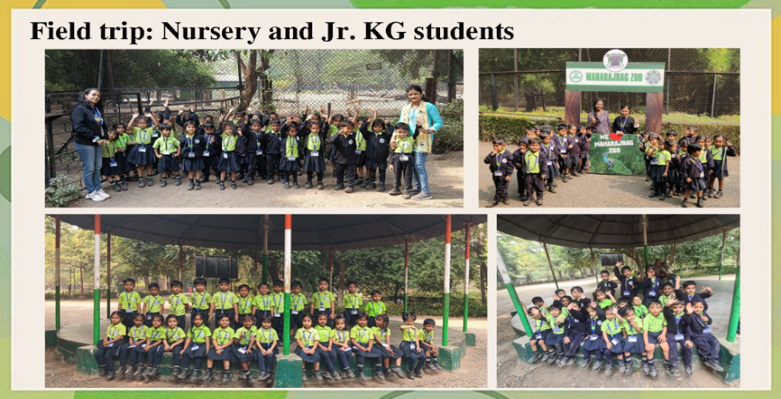School recently organized a delightful field trip to Maharaj Bagh Zoo for Nursery and Jr. KG students. Originally built by the Bhonsle kings, the park was later transformed into a botanical garden and zoo, home to a diverse array of rare plants and animals.

The children were filled with excitement as they explored the zoo, interacting with the animals, observing vibrant birds, and marveling at the variety of fish in the aquariums. It was a day full of joy and discovery, as the kids enjoyed nature and created lasting memories with their friends. We were equally thrilled to see their curiosity and happiness unfold throughout this educational adventure!

**Educational Visit**

🌟 Our little explorers had an exciting adventure at the Raman Science Centre! 🌟

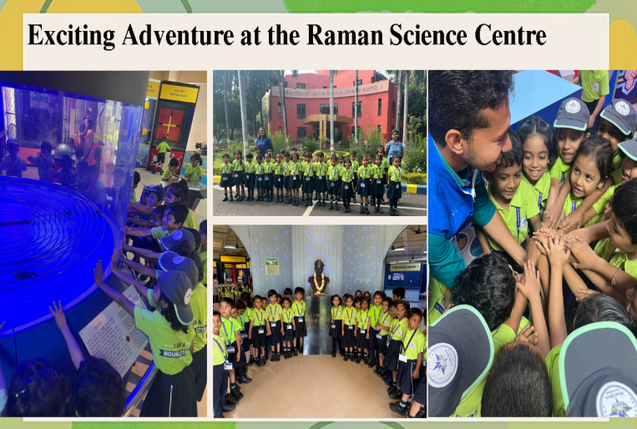

Located right in the heart of the city, this amazing place brings imagination to life! From walking through a prehistoric animal park to discovering interactive science wonders, our kindergarteners’ faces lit up with joy and curiosity.

It was more than just a fun day—it was a chance for our youngest learners to feel the magic of science! ✨

## Institution Planning for Classes I to VIII

**“What one does is what counts.**

**Not, what one had the intention of doing.”**

- **Pablo Picaso**

**Disciplined Assembly and Mass PT**

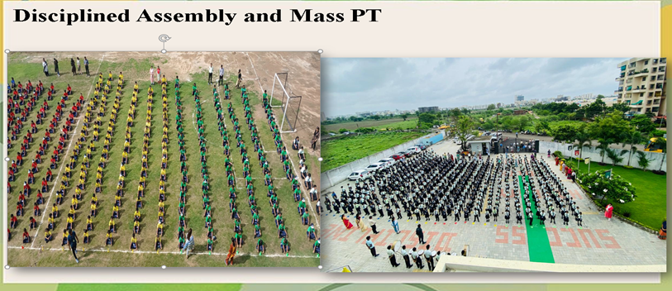Morning assembly is the most integral part of our daily routine and students learn discipline by following this routine instructions and behaving properly. This discipline extends to other parts of the school life also, so the school takes special interest in conducting the model morning assembly to promote confidence, which is done by allowing every student to engage, in conducting the assembly and giving their share of instructions

**Club activities-**

The joy and benefits of experience learning can never be overlooked. The school has a wide range of clubs that promote learning by combining recreational and educational factors representing interdisciplinary approaches to learning the carefully selected activities of the club. Focus on the entire development of learners in a cohesive manner every space inside and outside the school, then becomes a platform where the learner experiences and explore new ways of doing and learning things.

**Holistic Development of Students at our school**

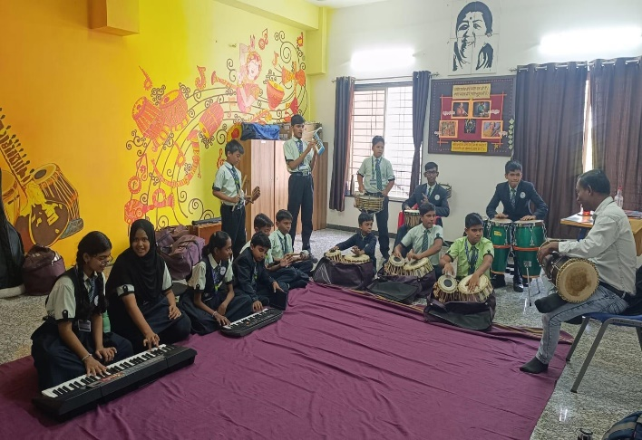 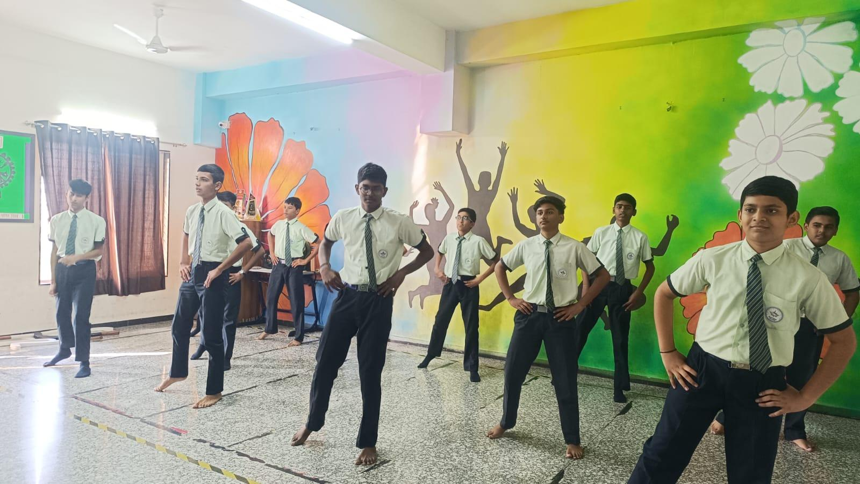



**Math and Logical Learning**

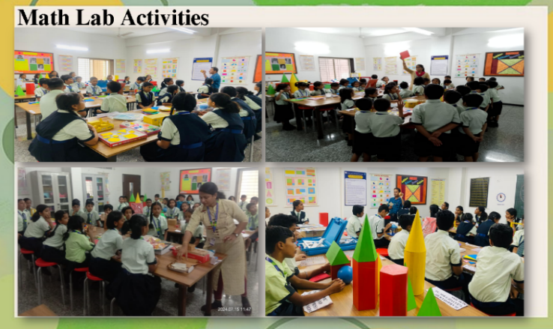Hands on experimentation done in the class helps to cement concepts in the child’s mind Weighing using weighing scale, measuring various objects, card board cut out of 3D objects using nets. Tangram is used in various classes to experiment learn and understand Math. Various math lab activities are taken up to learn about place values, fractions, banking transactions and other commercial mathematics.

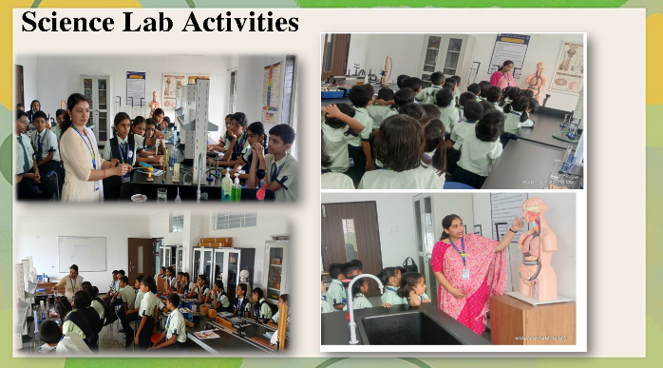Science lab activities for our students is a fantastic way to engage them with the natural world and help them develop a curiosity about science through hands-on experimentation. These activities focus on concepts that are tangible and easy to understand for young learners, using simple materials to foster discovery and exploration.

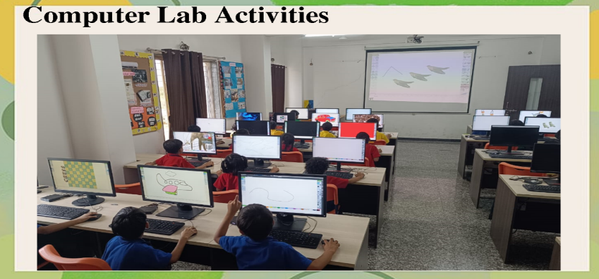

**Computer Lab Activities for our Students** are a great way to introduce young children to the world of technology while developing basic computer skills. These activities should be simple, fun, and interactive, helping children to engage with the computer in a way that enhances their learning.

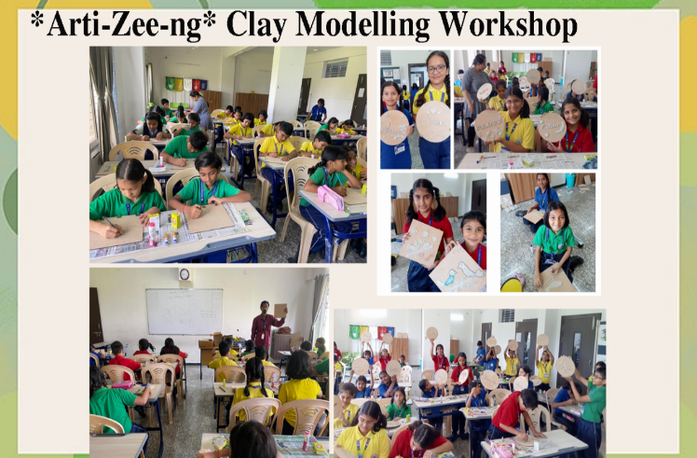

**Clay modelling workshop**

#little fingers shaping imagination into art #Creativity from the heart!

Mount Litera Zee School Besa presented a new learning experience for the talented artists of Grades 4 to 7 in *Arti-Zee-ng* Clay Modelling Workshop! The children were excited with their display and result!

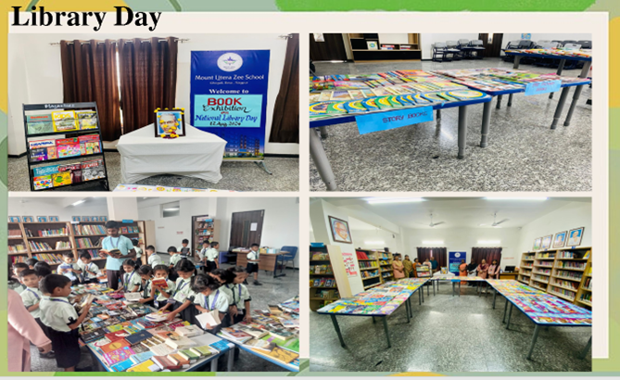**Library Day**

**Library Day is celebrated to promote the importance of reading and literacy.**  creating an engaging and exciting atmosphere for students. It's an excellent opportunity to foster a love for books, encourage reading habits, and recognize the role of libraries in education.

**Scout and Guide Pratham Sopan**

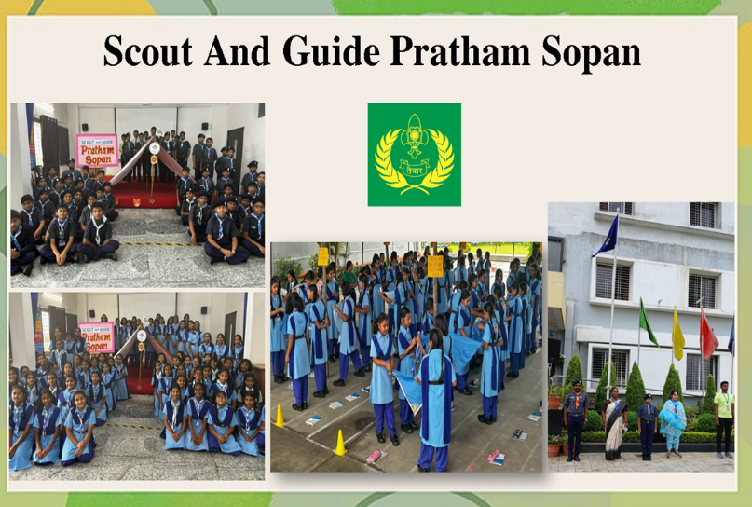The School proudly took efforts to organise ‘Pratham sopan’ which is a part of scouts and guides curriculum. Staying within the school campus, the students of Scouts and guides to pledge, emphasising on becoming a responsible citizen and rendering service to the nation when and wherever required, they also put up their own temporary tents and cooked means. The basic meal which was then served to all the members, which reflects their spirit to work as a team and learn how to manage crisis.

The School takes special care to provide conducive environment to the learners by providing a wide range of co-curricular opportunities. These ranges from dance, music, chess, physical education, etc. These activities help to rejuvenate the energy of the students and in-turn provides a platform to showcase the skill, talent, and creativity to the emerging creative minds.

**International Tiger day**

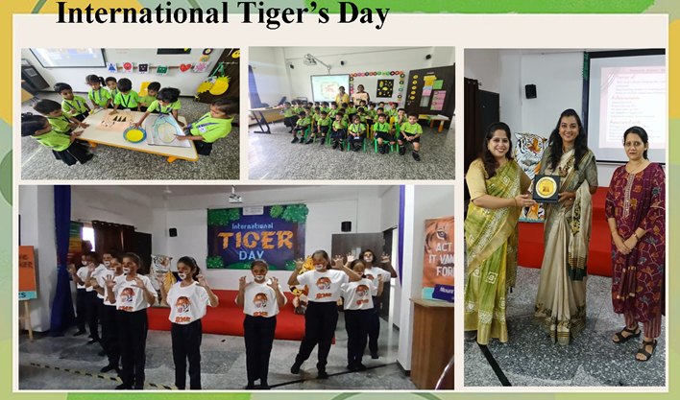An Awareness Session for saving wildlife was observed and celebrated with full vigour and enthusiasm in Mount Litera Zee School, Besa, on the occasion of ‘International Tiger's Day’.  Grades 6&7 participated in Poster Making Competition by printing creative slogans for the endangered species,the ferocious tigers.

Ms. Ekta Bhaiya,Nagpur Coordinator of Kids For Tigers Organization was invited as the Resource Person for the event conducted for Grades 4&5. An informative and interactive session rendered an overwhelming response by the students who understood the importance of saving our national animal and act before its too late.

**Kargil Vijay Diwas**

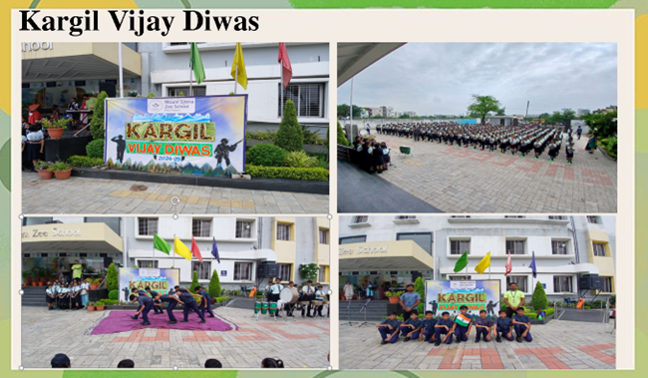**Kargil Vijay Diwas** commemorates the victory of the Indian Armed Forces over Pakistan in the Kargil War in 1999. Celebrating Kargil Vijay Diwas in school way to honor the bravery and sacrifice of soldiers and instill a sense of patriotism and respect for the country’s military history in young minds.

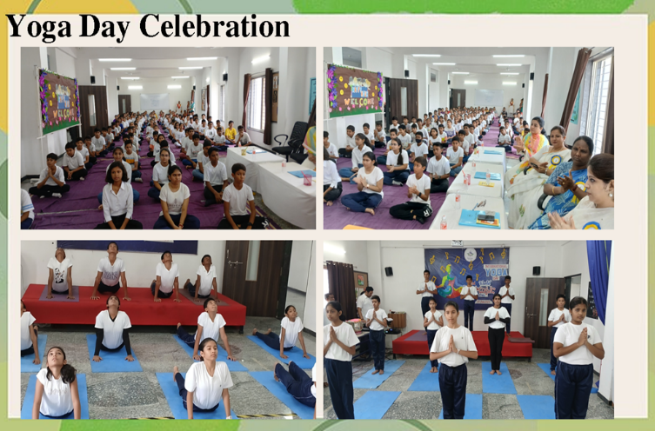**Yoga Day Celebration**

In celebration of International Yoga Day, students of MLZS participated in a vibrant and engaging yoga session to highlight the significance of maintaining a healthy body and mind. The event, marked by enthusiasm and zest, underscored the ancient yogic practice as a key to staying fit and achieving overall well-being.

**Student’s Council Election**

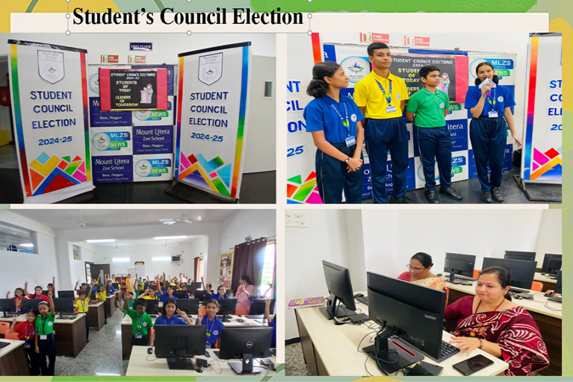Leadership is the capacity to translate the vision into reality. The investiture ceremony was held for the selection of student council for the academic year 24-25. It is a representation structure of students through which they become involved in the day to day school activity, the entire process includes a democratic set up where the students cast their votes and nominate the leaders. This gives the children a better understanding of the election procedure in a democratic country like India. It also helps the nominated leaders to sharpen the leadership and problem solving skills and developing interpersonal understanding.

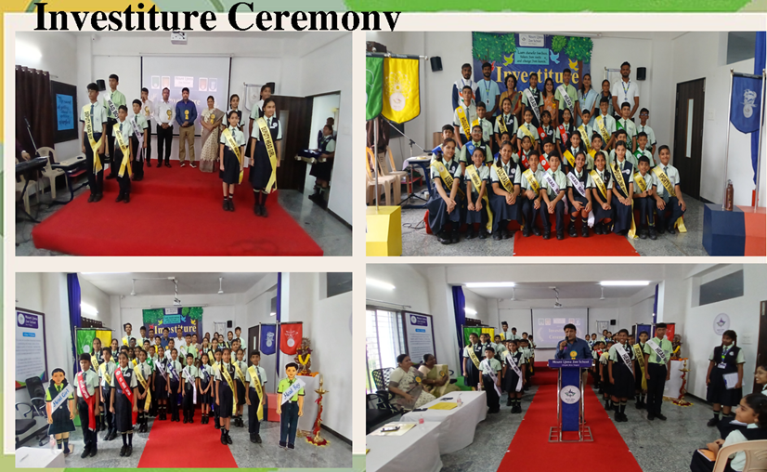

**Independence day**

Mount Litera Zee School Besa, Nagpur celebrated the 78th Independence Day with a great patriotic zeal in the school premises.

The glorious celebration was marked by a special assembly commemorating the magnificent midnight hour of Indian Independence.

The event was graced by the presence of Honorable Chief Guest- Vishnu ji Manohar, Guest of Honour- Amol Khante ji, Chairman of the insight education society Shri Shravanji Malu and the Board of Directors.

The event commenced with the auspicious flag hoisting ceremony, followed by National Anthem, reverberating the joyous fervour of freedom.

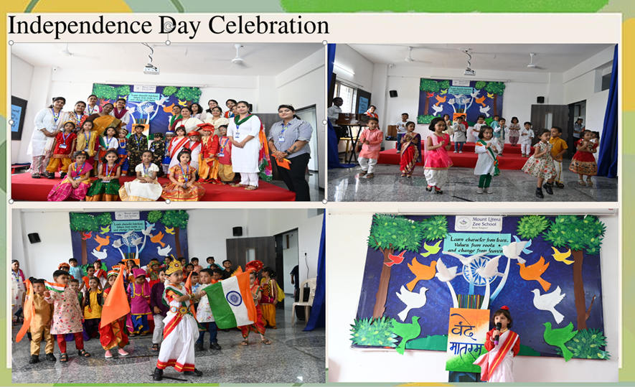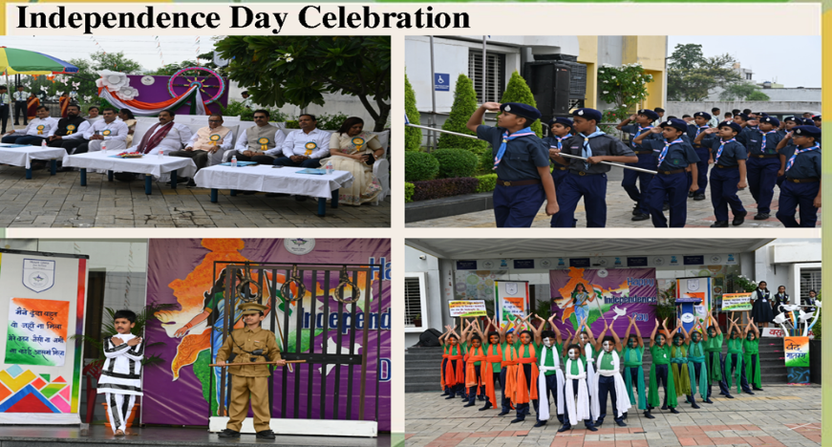

**Major Dhyan Chand Day-National Sports Day**

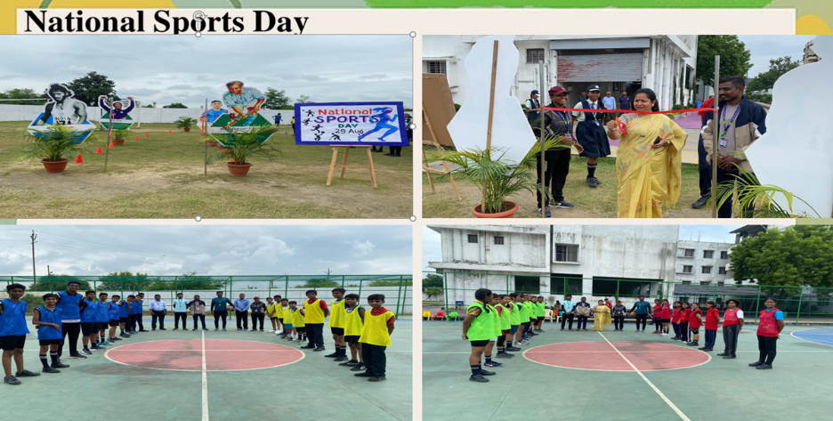In honor of the birth anniversary of hockey legend Major Dhyan Chand, MLZS celebrated ‘National Sports Day’ with a focus on building the spirit of sportsmanship among the young athletes. The event highlighted Major Dhyan Chand’s monumental contributions to the sport of hockey and his unwavering dedication to excellence in sports.

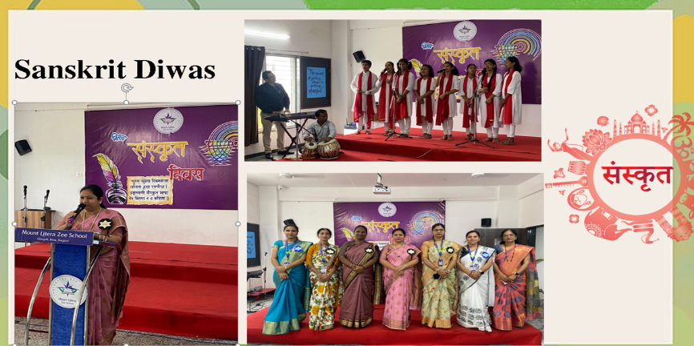**Sanskrit Day Celebration**

On this day we celebrate the ancient language of Sanskrit, highlighting its cultural and intellectual significance. The day included activities like chanting verses, cultural programs, and promoting awareness of its contributions to literature, science, and philosophy.

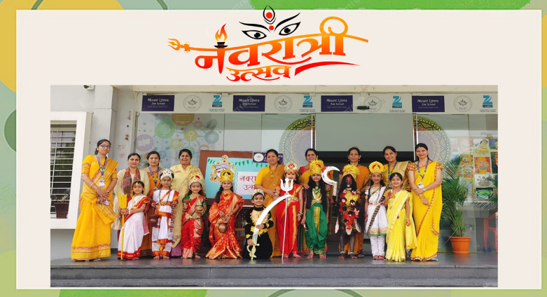**Navratri Celebration**

The festival of Navratri comes with lots of fun, frolic and dance, symbolizing victory of positivity over negativity.

Navratri festival was celebrated in Mount litera Zee School Besa Nagpur on 5 October 2024 with a lot of joy and happiness.

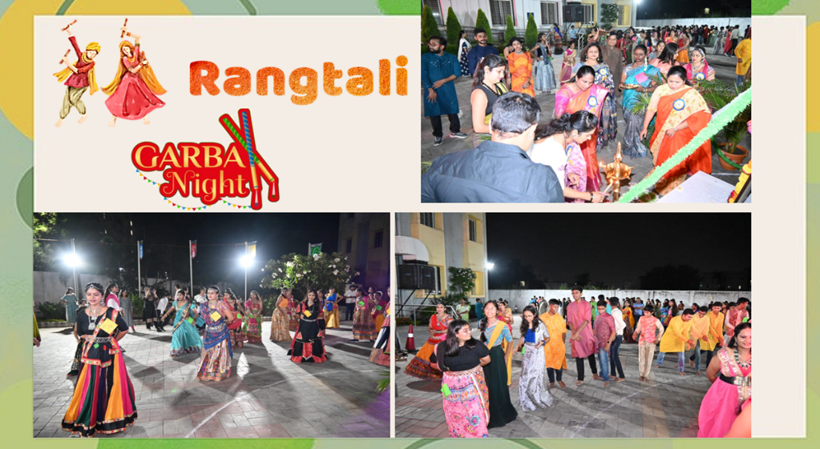The Garba dance competition titled ‘ रंगताली'  started in the evening with all the participants in traditional attire  dancing to the rhythmic beats, matching to the tunes of music. They were later joined by energetic and ever so charming students of MLZS. Their dance moves were filled with unmatchable fun and excitement. The crowd was mesmerized seeing these young ones dance with such energy and enthusiasm. The young participants were extremely thrilled to be a part of this vibrant and energizing event.

The school ground was set up in grandeur.

The garba show came to an end with the announcement of the winners under the category - Best dressed and Best dancer of the day.

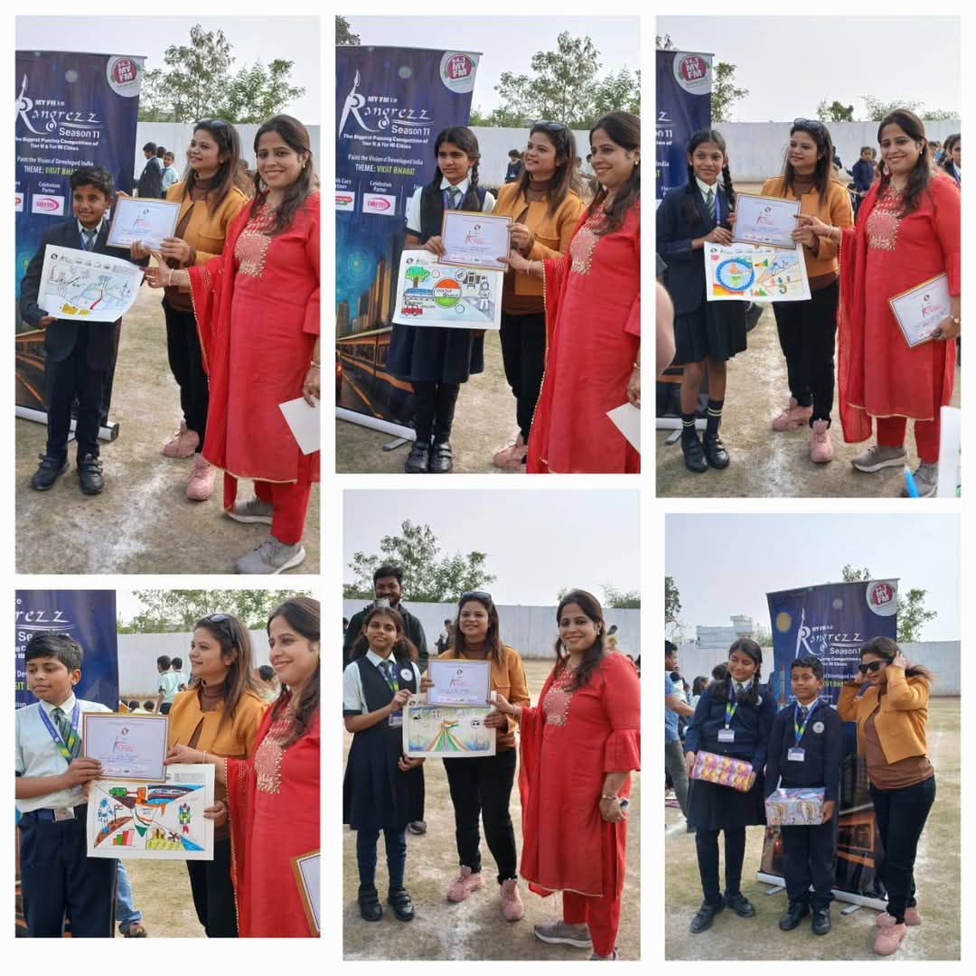**Rangrez Drawing Competition by 94.3 My FM**

Budding artists of Mount Litera Zee School Besa tried to showcase their vision of India marching towards becoming a developed nation through colourful creativity on canvas. The arena of Rangrez Drawing Competition on ‘Viksit Bharat’ organized by 94.3 My FM was filled with vibrancy and talent as the students participated enthusiastically.

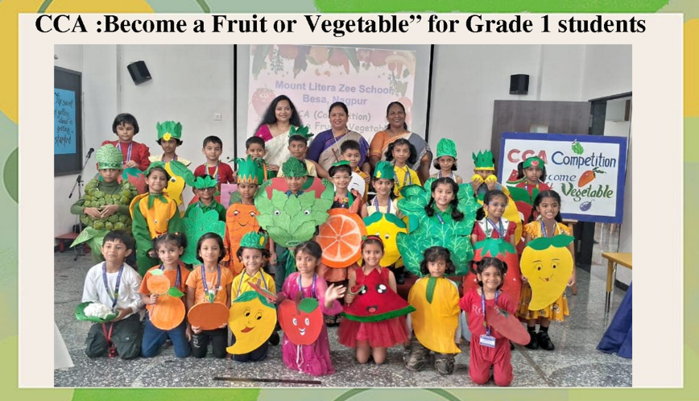**Co-Curricular Activities (CCA)**

**Co-Curricular Activities (CCA)** in schools are essential for the holistic development of students. These activities complement academic learning by providing opportunities for students to develop skills in areas such as creativity, leadership, teamwork, sportsmanship, and public speaking. CCA helps students explore their interests, enhance their confidence, and build well-rounded personalities.

**Diwali Celebration in School**

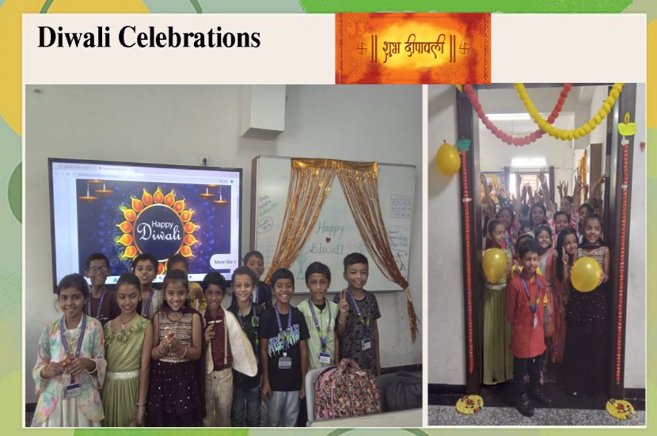The school involves children in the festive and educational atmosphere by providingopportunity to engage in fun and creative activities. To make the celebration even more exciting, the school organized a range of creative activities, including diya painting, rangoli making, and card crafting. Students were encouraged to express their artistic talents and creativity while embracing the values of togetherness, joy, and positivity that Diwali represents.

**Kids Fest**

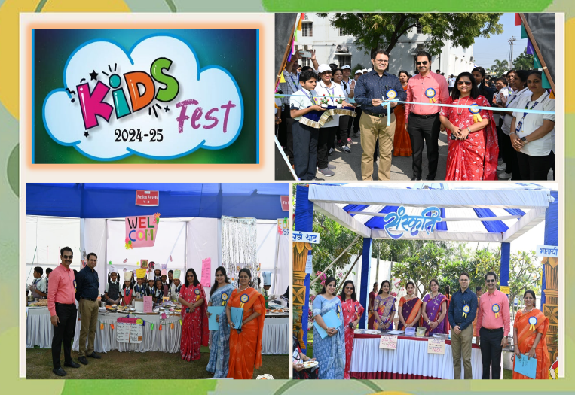

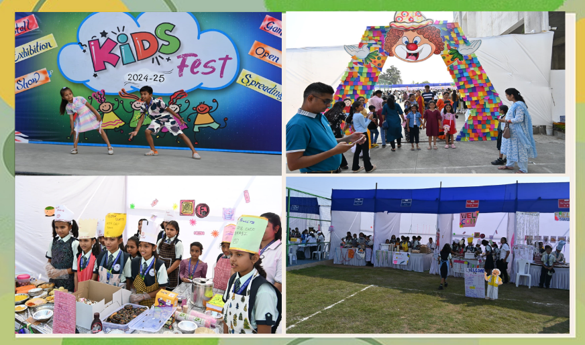Embarking towards a day full of zeal and enthusiasm, the happiness of Mount Literans soared high as they celebrated Kids Fest on the occasion of Children's Day. The fest was graced by the presence of the honourable Chief Guest, Dr.Abhishek Somani, Vice Dean (PG), Indira Gandhi Govt Medical College, who inaugurated the event by releasing colourful balloons in the air, filling it with joy and excitement. The fest is an excellent way to teach the children money management skills, setting them up for a secure financial future.

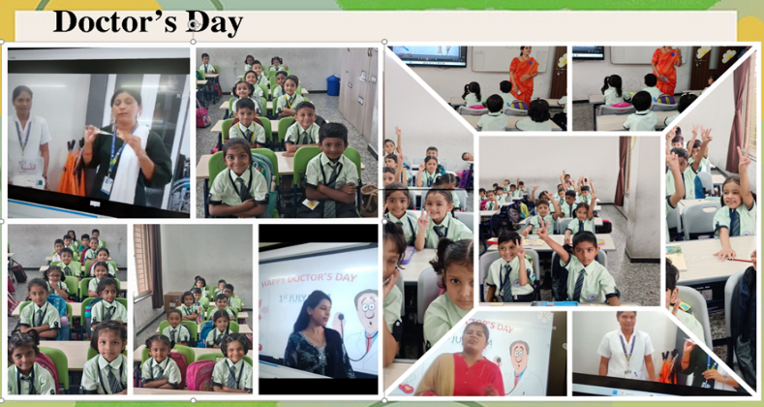**Doctor's Day Celebration**

Doctor’s Day was celebrated with great respect and admiration at MLZS, as the school honored the invaluable contributions of medical professionals to society. The day was marked by various activities which aimed at raising awareness about healthcare and acknowledging the tireless efforts of doctors in ensuring public well-being.

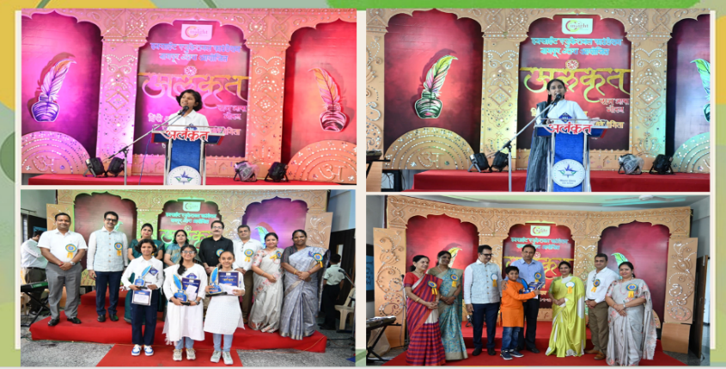

**Alankrit –**

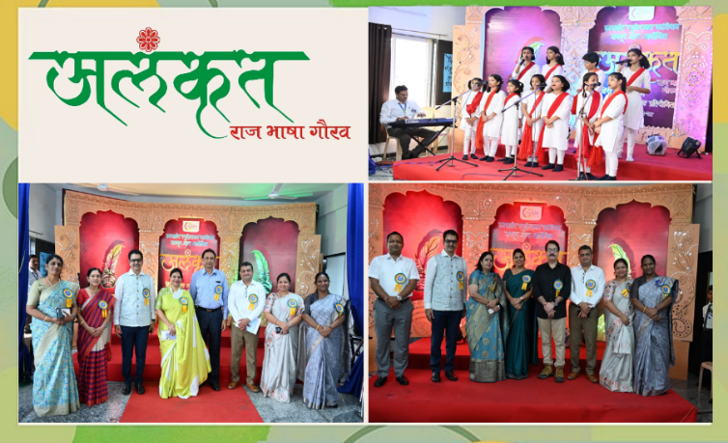‘The insight Education Society’ Nagpur had organized an interschool hindi Debate and Poetry narration competition on 28 Sep 24. It was for the second consecutive year 24-25 that the competition was organized at mlzs besa.

The main objective is to promote hindi language skills and encourage creativity among students. 19 schools across Nagpur participated enthusiastically showcasing their oratory, critical thinking and communication skills. Alankrit was a culmination of week long literary activities (Hindi Saptha). The winners of both the competitions were awarded with trophy, certificate and a cash reward.

**Culmination Grade I & II**

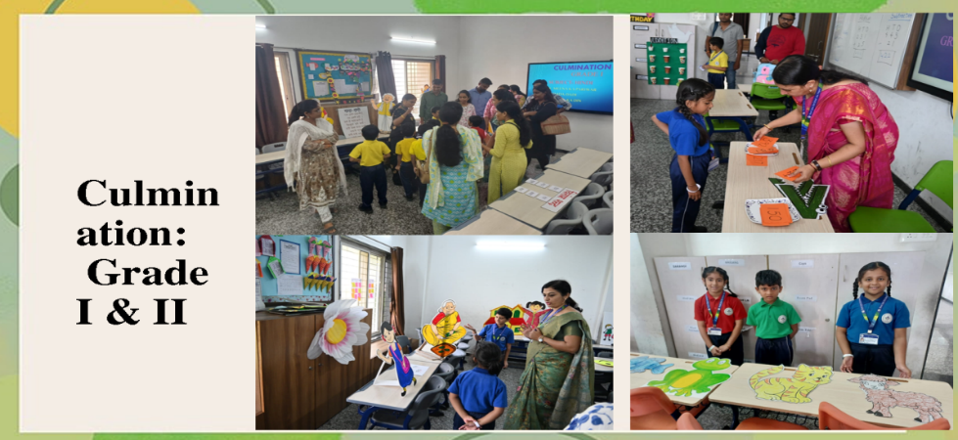We believe in experiential learning, not just grades. The culmination for Grade 1 & 2 focuses on hands-on experiences that foster growth, creativity, and practical knowledge beyond traditional assessments.

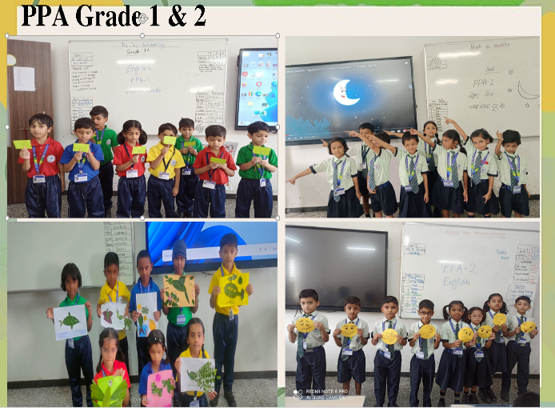

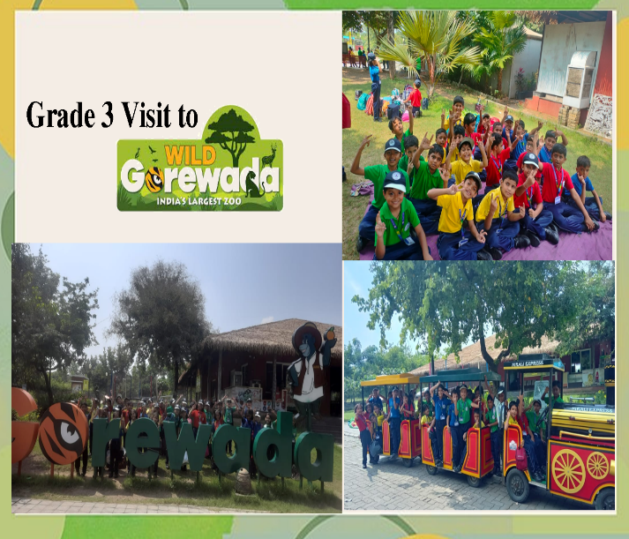

**An Educational Visit**

**To Wild Gorewada - Grade 3**

Educational visits combined with picnics offer a perfect blend of learning and leisure. Students get the chance to explore historical sites, museums, or cultural centers, enriching their knowledge and understanding of various subjects. After the educational exposure, a picnic allows them to relax, enjoy nature, and bond with their peers. This combination not only makes learning more enjoyable but also creates lasting memories, fostering a sense of camaraderie and a deeper connection to the topics explored.

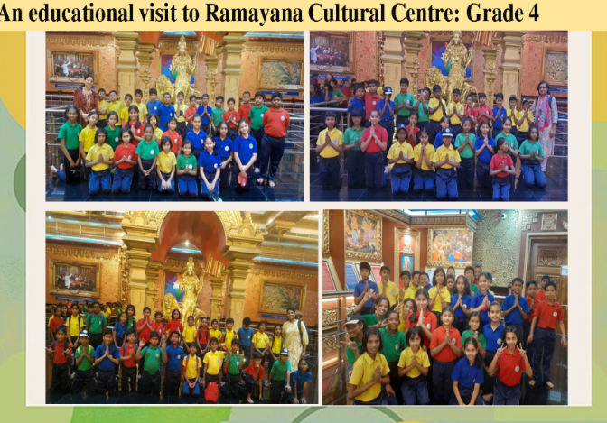

**To Ramayana Cultural Centre - Grade 4**

To enrich future generations with our culture and traditions, an educational visit to the Ramayana Cultural Centre Grade 4 was organized. The students witnessed a captivating display of mythological stories from the Ramayana, deepening their connection to our heritage.

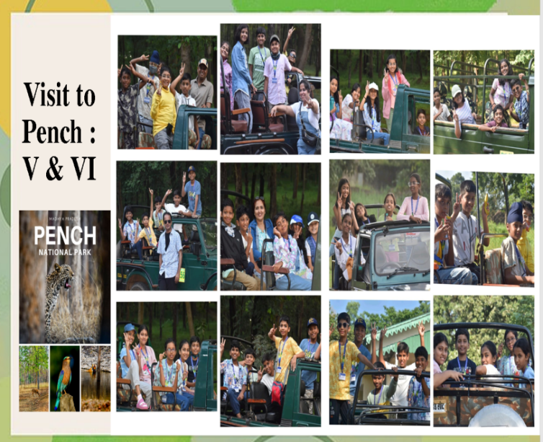**To Pench National Park – Grade 5**

An educational visit combined with a picnic to **Pench National Park** provides an enriching experience that blends **learning about wildlife and ecology** with the enjoyment of nature. Pench National Park is known for its rich biodiversity and is a fantastic destination for students to learn about the **ecosystem**, **wildlife conservation**, and **forest management**.

**Community Outreach Program : Grade 5 ‘Visit to an Orphanage’**

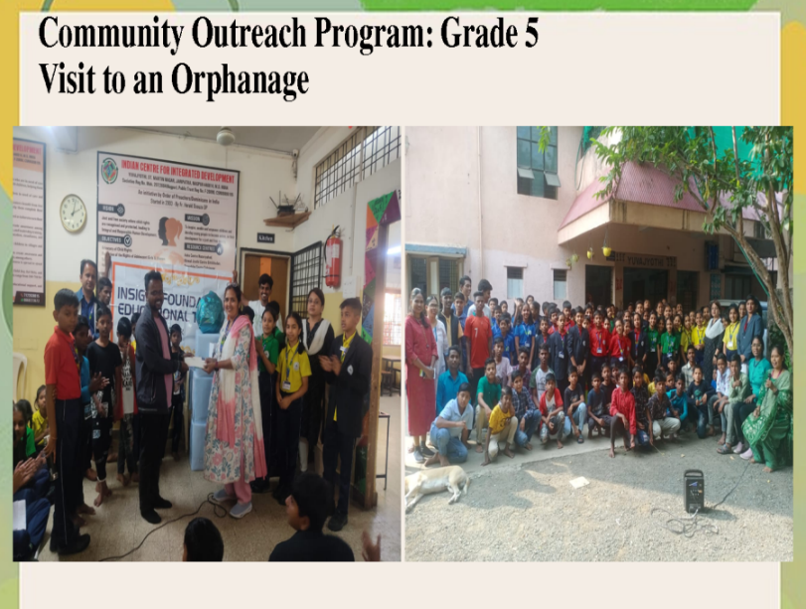An orphanage visit provides an enriching experience that blends learning about community service and empathy with the enjoyment of spending time with children. Visiting an orphanage allows students to understand the challenges faced by less fortunate children, learn about the importance of giving back to society, and develop a sense of responsibility and compassion. It also offers a chance to relax and enjoy the company of the children while making a positive impact on their lives. Donating utility items to an orphanage is a wonderful way to give back and make a significant impact.

**Glimpses of Achievements**

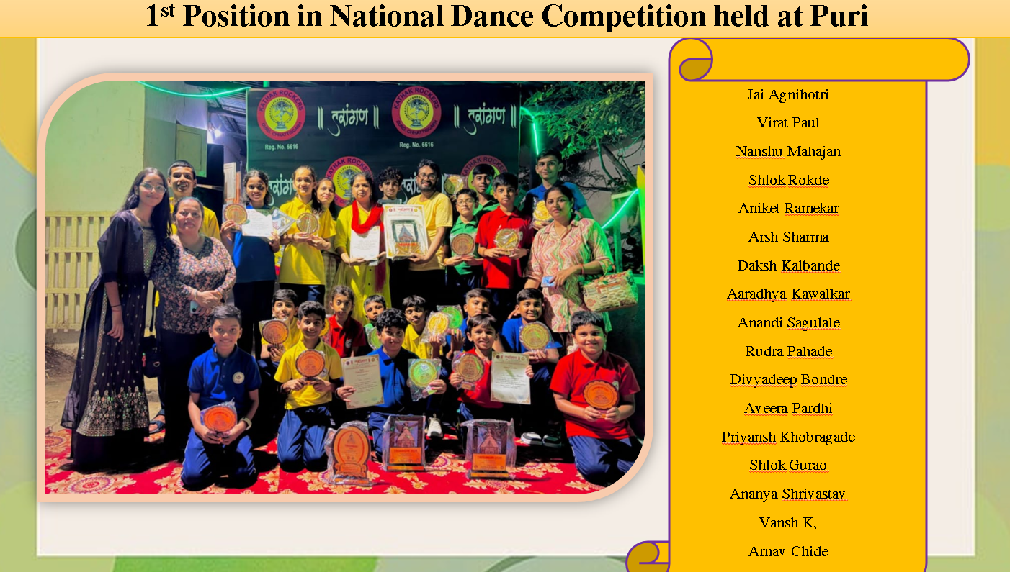 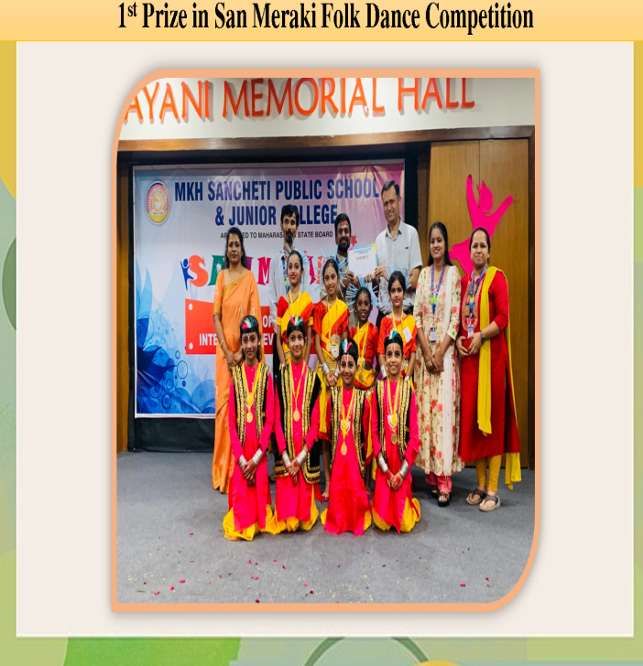

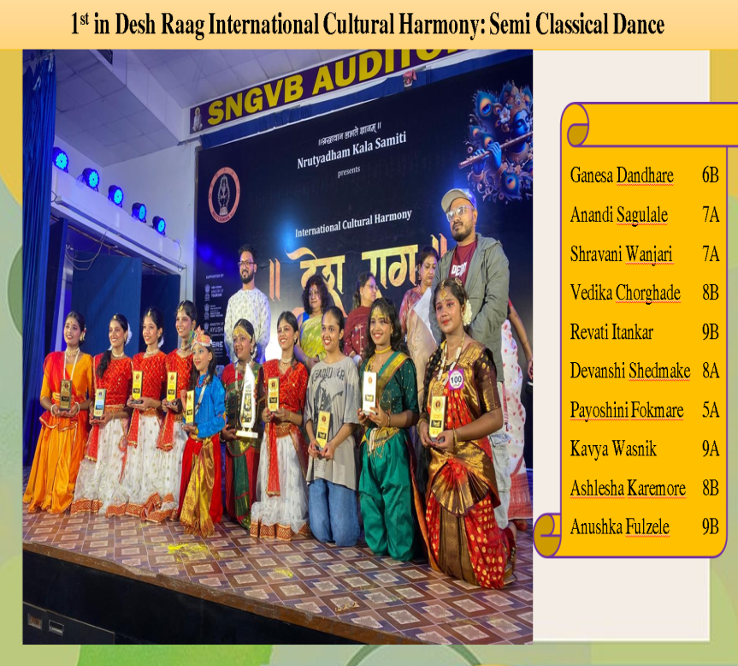 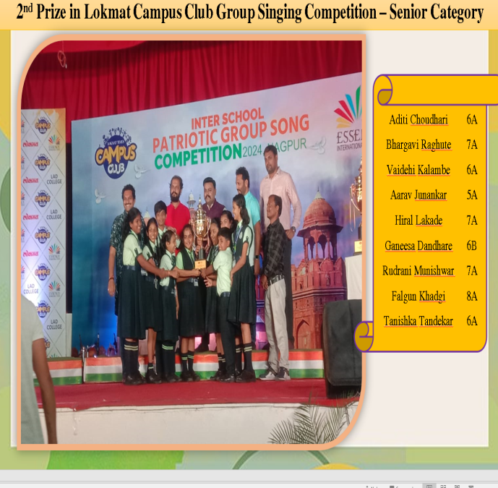

**Annual Function** -**"संकल्प" - Marching Ahead Towards "नया भारत"**

The auditorium of Suresh Bhat Sabhagruh reverberated with the momentous occasion of Annual Day 2024-25 of Mount Litera Zee School, Ghogli, Besa on 9th December for Grades 3 onwards. It was woven around the unique theme of "संकल्प" - Marching Ahead Towards "नया भारत" with vibrancy and life being propelled into magnificent celebration. The Principal, Dr.Vandana Paul envisioned the current theme with a futuristic hope for the country that is reaching its centenary of freedom, with strong convictions.

